Perth Extended Zone customer playbook
May 2025

The forthcoming launch of the Perth Extended Zone represents a significant opportunity. By storing and processing your data within Western Australia, you can fulfil your data residency and compliance obligations, minimise workload latency, and achieve your sustainability goals.
This document offers specific guidance for the Perth Extended Zone, serving as an initial reference when utilizing an Azure Extended Zone. It focuses on three key areas:
- Overview of Azure Extended Zones
- Design considerations for Azure Extended Zones
- Use cases for Azure Extended Zone

Intended audience
This technical document is intended for solution architects and other technical stakeholders as they plan their use of Azure Extended Zones.

Version Control
Status | Version | Date | Changes
Draft | 0.1 | 16/12/24 | First draft
Final | 1.0 | 31/12/24 | Initial public release
Updates | 1.1 | 31/03/25 | - Deployment scenarios  - Modified scenario naming  - Pricing and billing  - Updated to include CSP  - Updates to Costs Savings Plans support  - Quotas  - Added  - Azure Backup  - Updated to include supported and unsupported scenarios  - Azure Site Recovery  - Updated to include supported and unsupported scenarios  - Azure Migrate  - Added  - ExpressRoute  - Updated to clarify Perth PoP and ExpressRoute
Updates | 1.2 |  | - Service availability and timelines  - Service Level Agreement  - Independent Software Vendor solutions  - Aviatrix  - Citrix  - Fortinet  - Network Topology -ExpressRoute  - Azure Site Recovery supported use case

Table of Contents
Overview of Azure Extended Zones 8
Deployment scenarios 10
Scenario 1: Azure Extended Zone - Standalone 10
Scenario 2: Azure Extended Zone - Extension 11
Service availability and timelines 12
Service Level Agreement 13
Independent Software Vendor solutions 14
Pricing and billing 15
Onboarding 15
Design Considerations 16
Resource organization 16
Parent Region 16
Subscriptions 16
Management 17
Connecting to Virtual Machines 18
Well-Architected Recommendations 18
Azure Compute Gallery Images 18
Governance 19
Azure Policy 19
Azure tags 19
Observability 19
Alerts, actions and notifications 19
Service Health 19
Logs 20
Metrics 20
Insights 20
Workbooks 20
Application Performance Monitoring 20
Network Watcher 20
Virtual Machine Boot Diagnostics 22
Quotas 23
Update Management 23
Networking and connectivity 24
Network Topology 24
Connectivity Options 27
Inbound Internet Access 32
Name Resolution 34
Business continuity, disaster recovery and migration 35
Availability 35
Recovery 36
Migration 37
Security, compliance and data residency 38
Microsoft Cloud Security Benchmark 38
Cloud Security Posture Management 38
Security Information and Event Management 38
Azure Security Services 39
Data residency 40
Extended Security Updates 40
Compliance and regulatory standards 40
Use cases (coming soon) 42

Overview of Azure Extended Zones

Azure Extended Zones are small-footprint extensions of an Azure region, strategically located in metropolitan areas, industry hubs, or specific jurisdictions. Extended Zones support virtual machines, containers, storage, and a selection of Azure services, enabling the execution of latency-sensitive and throughput-intensive applications close to end users while adhering to approved data residency requirements.

Azure Extended Zones are integrated into the Microsoft global network, providing secure, reliable, high-bandwidth connectivity between applications running in an Extended Zone and their users. Azure customers can provision and manage their Azure Extended Zones resources, services, and workloads through the Azure portal and other essential Azure tools.
The control plane for services running within an Extended Zone remains in the region and the data plane is deployed at the Extended Zone site, resulting in a smaller Azure footprint.
Azure Extended Zones are designed to address two key scenarios:
- Latency: Users need to operate their resources, such as media editing software, remotely with minimal latency.
- Data residency: Users require their application data to remain within a specific geography, hosting locally for various privacy, regulatory, and compliance reasons.

When considering the deployment of workloads to an Azure Extended Zone, consider the following questions:
- What are your timelines? Services within Azure Extended Zones will become available in phases. If you have a strict deadline, ensure that it aligns with the launch schedules and incorporates a buffer for contingencies. For additional details, refer to Service availability and timelines..
- What services will you use? Azure Extended Zones support virtual machines, containers, storage, and a select range of Azure services. Assess whether your solution necessitates specific services that may not yet be available in the Extended Zone. For further information, see Service availability and timelines.
Additionally, if your solution relies on third-party services from the Azure Marketplace, those services may not be accessible in the Extended Zone until the ISV has validated them.
- How are you likely to grow your use of services within the Azure Extended Zone? To facilitate planning for the Azure Extended Zone's capacity, Microsoft needs to monitor the projected growth in service usage. Ensure that you discuss your anticipated usage with Microsoft or your primary partner.
- What are your requirements for high availability and disaster recovery? It is crucial to recognize that Azure Extended Zones do not support availability zones but do support additional services to support your availability and disaster recovery requirements.
What are your requirements for high availability and disaster recovery? Azure Extended Zones do not support availability zones, but they do support additional services to meet your availability and disaster recovery requirements.

Deployment scenarios
Azure Extended Zones are available for deployment in the following scenarios:
- Standalone
- Region extension

Scenario 1: Azure Extended Zone - Standalone
Organizations can choose to deploy workloads within the Azure Extended Zone (e.g., Perth Extended Zone) without the necessity of connecting to a parent region's landing zone (e.g., Australia East).
Access to workloads within the Extended Zone can be facilitated through private connectivity options such as ExpressRoute or Site-to-Site VPN¹, or through public connectivity options like the Standard Load Balancer.

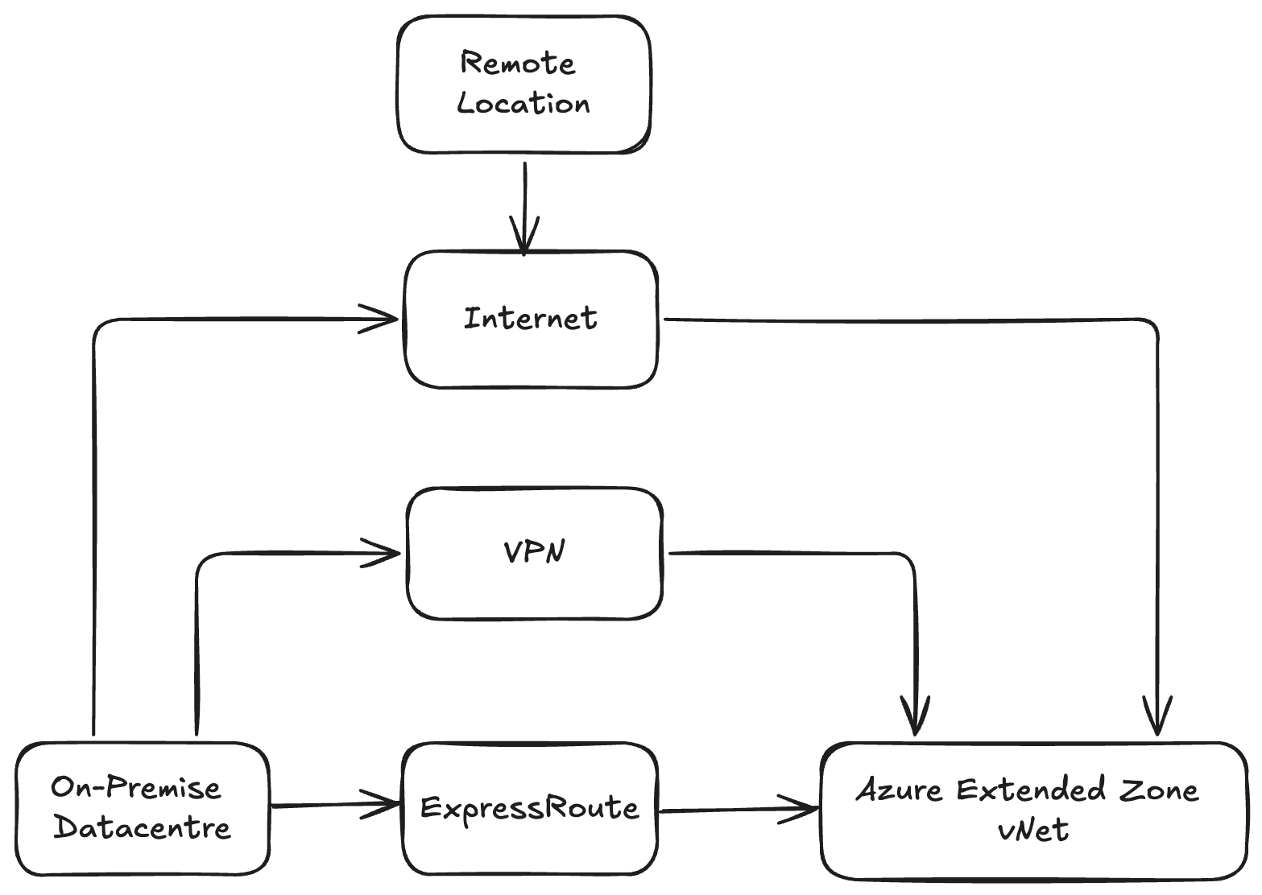

¹ Azure VPN is a roadmap item for Azure Extended Zone. Site-to-Site VPN connectivity would need to be via 3rd solution.

Scenario 2: Azure Extended Zone - Extension
Azure customers with existing landing zones might consider extending their presence to include Azure Extended Zones (e.g. Perth Extended Zone).
Access to workloads within the Extended Zone can be facilitated through private connectivity options such as ExpressRoute or Site-to-Site VPN¹, as well as public connectivity options like the Standard Load Balancer. Alternatively, connections can be established over the Microsoft network backbone via peering connections to a landing zone in a region.

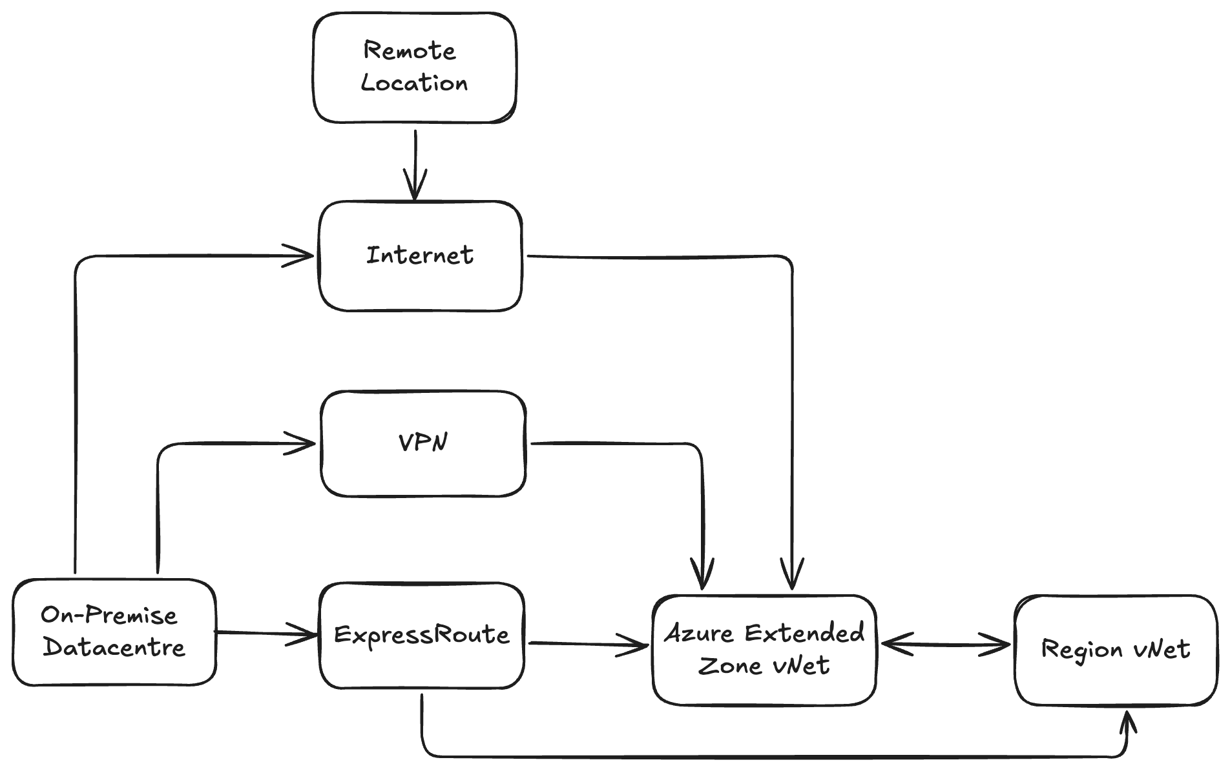
¹ Azure VPN is a roadmap item for Azure Extended Zone. Site-to-Site VPN connectivity would need to be via 3rd solution.

Service availability and timelines
Azure Extended Zones facilitate the deployment of key Azure services for customers. The control plane for these services operates in the primary region, while the data plane is deployed at the Extended Zone site, resulting in a streamlined Azure footprint. The following diagram illustrates the deployment of Azure services at the Azure Extended Zones location.
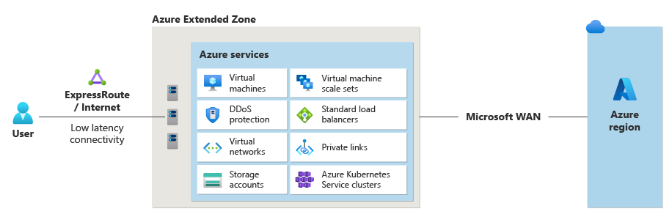
The following table presents Azure services that are accessible within the Azure Extended Zones:
Service category | Available Azure services and features
Compute | Azure Kubernetes Service  Azure Virtual Desktop  Virtual Machine Scale Sets  Virtual machines (general purpose: A, B, D, E, and F series and GPU NVadsA10 v5 series)
Networking | Application Gateway^{*2}  DDoS (Standard protection)  ExpressRoute  Firewall^{*1}  NAT Gateway^{*2}  Private Link  Standard Load Balancer  Standard public IP  Virtual Network  Virtual network peering  VPN Gateway^{*2}
Storage | Managed disks  Premium Page Blobs  Premium Block Blobs  Premium Files  Data Lake Storage Gen2  Hierarchical Namespace  Data Lake Storage Gen2 Flat Namespace  Change Feed  Blob Features  - SFTP  - NFS
Business Continuity and Disaster Recovery | Azure Site Recovery  Azure Backup
Arc-enabled Services | Arc-enabled Data Services  - PostgresSQL (Preview)  - ManagedSQL (Preview)  Arc-enabled Container Apps (Preview)
^{*1} Available at GA
^{*2}Roadmap post GA
If you plan to utilize the any Extended Zone shortly after its launch, we recommend evaluating the services and SKUs you intend to use to ensure their availability. Should your project timelines require access to services prior to the Extended Zone reaching general availability, please contact your Microsoft account team for guidance on timelines, scope, and potential alternatives.
In the event that your required services are not yet available, we advise making contingency plans. These may include:
- Waiting until your desired set of services is available in the Perth Extended Zone before deploying your workload. For new workloads, consider deploying non-production environments in the parent region and planning to migrate production services to the Perth Extended Zone when they become available.
- Utilizing an alternative service or SKU that is currently available in the Perth Extended Zone, with a plan to later migrate to your preferred service or SKU.

Service Level Agreement
Service Level Agreements (SLAs) are Microsoft's commitment to provide a certain level of service quality, including uptime and connectivity, for their online services. These agreements capture the performance standards that customers can expect from Azure services and specify the compensation customers are entitled to if these standards are not met. In the event of an SLA breach, customers can submit claims to Microsoft. If the claim is validated, customers may receive service credits, which are applied towards future usage of the same service.
Extended Zones are single-zone locations, and the below SLAs take this into consideration.

Area | Service | Uptime Percentage | Service Credit at <99.9%
Compute | VM | < 99.9% | 10%
 | VMSS
Storage | Azure Premium Files
 | Azure Premium Block Blobs
 | Azure Premium Page Blobs
Networking | Network Availability

For details on each Service SLA and how it’s calculated, please refer to the Microsoft SLA page. Please note that the Service Specific SLAs above might be different from the SLAs from the Microsoft SLA page.

Independent Software Vendor solutions
Independent Software Vendor (ISV) marketplace offerings are deployable within the Azure Extended Zone. Below is a list of ISV offerings currently undergoing validation and their respective statuses.
Vendor | Product(s) Name | Status
Aviatrix | Secure Networking Platform | Completed
Fortinet | Fortinet FortiGate Next-Generation Firewall | Completed
Checkpoint | Check Point CloudGuard Network Security Firewall & Threat Prevention | ISV validating
Citrix | Citrix DaaS | ISV validating
F5 Network | F5 Big IP BYOL | ISV validating
NetApp | CVO | ISV validating
Palo Alto | VM-Series Next-Generation Firewall from Palo Alto Networks | ISV validating
Red Hat | Red Hat Enterprise Linux | ISV validating

Pricing and billing
Azure Extended Zones usage is priced separately from Azure Regions. The services available within the Extended Zone will be offered at a premium price. Pricing information is outlined below:
- Public Preview pricing will align with General Availability rates.
- Enterprise Agreement (EA) discounts will apply.
- Cloud Service Provider (CSP) agreements can be used for Azure Extended Zones
- Cost savings plans and Reserved Instances are not currently supported.

Network Ingress and Egress Charges
- Data Centre Data Transfer pricing for Perth Extended Zones, excluding transfers explicitly covered under Content Delivery Network and ExpressRoute pricing, is categorized as Inter-Region.
- ExpressRoute Data Transfer pricing for Perth Extended Zones falls under Zone 2 classification.
- Virtual Network Peering costs for vNets peered between the Perth Extended Zone and Australia East are treated as within the same region.
Work with your Microsoft account team to obtain detailed pricing information for the Azure Extended Zone.

Onboarding
Access to Azure Extended Zones will be restricted and managed through a controlled access process. This process involves three primary steps:

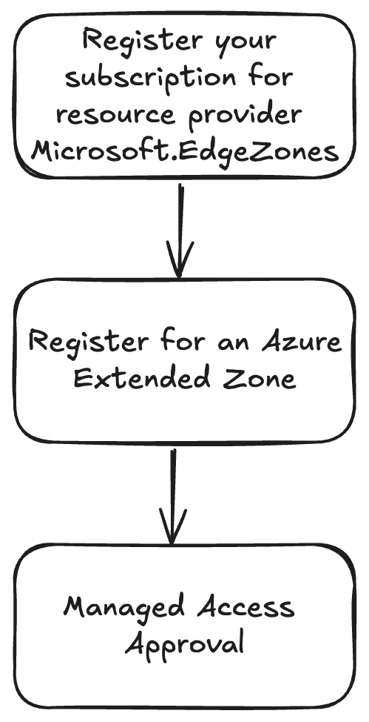
Comprehensive guidelines on how to request access to the Azure Extended Zone can be found in the Request access to an Azure Extended Zone article.

Design Considerations

Resource organization
Resource organization within Azure necessitates a structured approach to secure, manage, and optimize cloud resources effectively. This section will delve into the concept of a parent region, subscriptions, management groups, and resource groups.

Parent Region
As outlined in the Overview of Azure Extended Zones section, the control plane for services deployed to an Azure Extended Zone remains situated within an Azure Region while the data plane is deployed at the Extended Zone site. Consequently, utilizing services in an Azure Extended Zone necessitates the employment of certain services, resources, and features within an Azure Region, referred to as the 'parent region.'
When deploying resources within an Azure Extended Zone, the resource overview will indicate the Azure Extended Zone. The portal views for the resource type, such as the Virtual Network View, will display the parent region. Refer to the screenshot below for an example.
Virtual Network View:
Virtual Network Resource View:
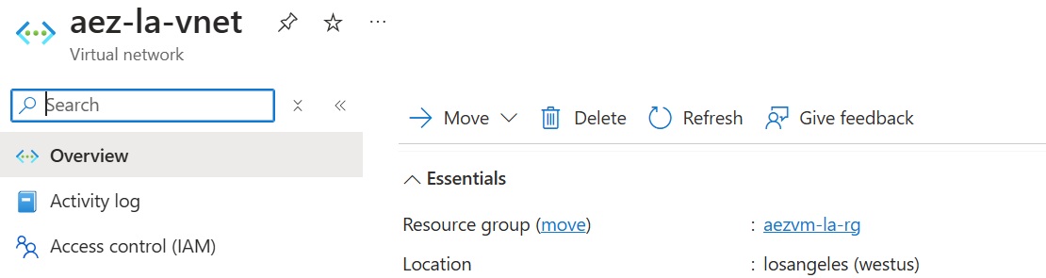

Subscriptions
An Azure subscription serves several purposes, including:
- A legal agreement
- A payment agreement
- A boundary of scale
- An administrative boundary
Every Azure resource is logically associated with one subscription. When creating a resource, you select which Azure subscription to deploy it to.
Subscriptions are not tied to a specific Azure region or Azure Extended Zone, though each Azure resource deploys to only one region or extended zone.
Access to Azure Extended Zones is regulated and managed through a controlled access process. It is essential to register the subscription(s) intended for Extended Zone deployments. For further information, please refer to the Onboarding section.
It is advisable to consider dedicating specific subscriptions for deployments within an Azure Extended Zone. This approach facilitates the monitoring of quotas within the extended zone and mitigates potential confusion with resources deployed in the parent region.

Management Groups
If your organization manages multiple Azure subscriptions, an efficient method is essential for overseeing access, policies, and compliance. Management groups offer a governance scope above subscriptions. By organizing subscriptions within management groups, any governance conditions applied will cascade by inheritance to all associated subscriptions.
Management groups are not tied to any specific Azure Region and can be utilized with both Azure Extended Zone allocated subscriptions and Azure Extended Zone deployed resources.

Resource Groups
A resource group is a container that facilitates the management of related resources within an Azure solution. It serves as a scope for applying Role-based Access Control (RBAC) and Azure Policy for governance purposes. While resource groups can encompass resources provisioned in any Azure Region, they are associated with a specific region for metadata storage purposes.
It is important to note that creating a resource group within an Azure Extended Zone is not possible. Therefore, resource groups should be established in an Azure parent region. To avoid any confusion, it is recommended to adopt a naming convention that clearly indicates which resource groups are associated with an Azure Extended Zone.

Management
By leveraging these management capabilities, you can ensure that your Azure environment is optimized, secure, and aligned with your business objectives.
Azure offers a comprehensive suite of tools and services designed for effective cloud resource management. The management capabilities in Azure encompass a broad range of tasks aimed at maintaining the health, performance, and security of your applications and infrastructure. These tasks include deploying and configuring resources, monitoring their performance, and ensuring compliance with organizational policies.
Key areas of Azure management include:
- Connecting to Virtual Machines: Establishing secure and efficient connections to your virtual machines for remote management and troubleshooting.
- Well-Architected Recommendations: Following best practices to design and operate reliable, secure, efficient, and cost-effective systems in the cloud.
- Governance: Implementing policies and controls to ensure resources are used appropriately and in compliance with organizational standards.
- Monitoring: Continuously tracking the performance, health, and availability of your resources to detect and respond to issues promptly.
- Update Management: Keeping your systems up-to-date with the latest patches and updates to maintain security and performance.
By leveraging these management capabilities, you can ensure that your Azure environment is optimized, secure, and aligned with your business objectives.

Connecting to Virtual Machines

Azure Bastion
Azure Bastion is a fully managed Platform as a Service (PaaS) offering that enables secure connectivity to virtual machines using private IP addresses. It facilitates secure RDP/SSH access directly over TLS from the Azure portal, as well as through the native SSH or RDP client on your local machine. By leveraging Azure Bastion, virtual machines do not require public IP addresses, agents, or any specialized client software to connect.
The Azure Extended Zones do not support the Azure Bastion Basic, Standard and Premium SKUs.
Review the Service availability and timelines section for availability updates.

To connect to a virtual machine deployed in an Azure Extended Zone, it is advisable to deploy the Azure Bastion service to the parent region and leverage the Azure Bastion service support for global virtual network peering. It is important to note that the Azure Bastion Basic, Standard, and Premium SKUs support connecting to virtual machines in peered virtual networks; however, the Developer SKU does not. For additional information, please refer to "About Azure Bastion" on Microsoft Learn.

Well-Architected Recommendations

Azure Advisor
Azure Advisor is a non-regional service that provides recommendations applicable to resources deployed in an Azure Extended Zone.

Azure Compute Gallery Images
Azure Compute Gallery images serve as a valuable resource for building virtual machines within Azure Extended Zones. However, it is important to note that this functionality is not yet accessible through the Azure Portal (UX).
Azure Compute Gallery images hosted in a primary Azure region can be replicated to Azure Extended Zones by utilizing the appropriate command, as demonstrated below:
az sig image-version update --resource-group MyResourceGroup --gallery-name MyGallery --gallery-image-definition PlaceholderImage --gallery-image-version 0.0.1 --target-edge-zones australiaeast=perth=1=standardssd_lrs
*Please note* premium_lrs is also supported as storage type for image versions in the Perth Azure Extended Zone.
If you receive an error message about "Subscription '<SubID>' is not enrolled for Edge Zone access." please contact MSFT Support and provide them your subscription ID so access to the feature can be granted on the back end. Alternatively, it is possible to self-serve this by creating a managed identity and giving it access to an Azure compute gallery via an API operation.

Governance

Azure Policy
Azure Policy assists in enforcing organizational standards and assessing compliance at scale. Through its compliance dashboard, it provides an aggregated view for evaluating the overall state of the environment, with the capability to drill down to per-resource and per-policy details. It also aids in bringing resources into compliance through bulk remediation for existing resources and automatic remediation for new resources.
Azure Policy is a non-regional service and will evaluate resources deployed to an Azure Extended Zone for adherence to assigned policy definitions.

Azure tags
Tags are metadata elements that can be applied to Azure resources, consisting of key-value pairs that assist in identifying resources based on parameters pertinent to organizational needs.
Tags are supported within an Azure Extended Zone and are recommended as part of a comprehensive governance strategy for managing the Azure environment

Observability

Alerts, actions and notifications

Action Groups
Action groups cannot be created in an Azure Extended Zone. It is recommended to create a global action group for monitoring resources within such zones. Typically, action groups are global services, with regional variations only available in select Azure regions
Global action groups can process client requests from any region. If a specific region's service is unavailable, the requests are automatically routed to and processed by services in other regions, ensuring uninterrupted service. This global approach provides a robust disaster recovery solution. Regional requests, on the other hand, rely on availability zone redundancy to comply with privacy requirements and offer a similar level of disaster recovery.

Service Health
Azure Service Health comprises three integral services:
- Azure status informs users of service outages in Azure on the Azure Status page. This page provides a global view of the health of all Azure services across all regions
- Service health offers a personalized view of the health of the Azure services and regions in use. This is the optimal source for service-impacting communications about outages, planned maintenance activities, and other health advisories.
- Resource health provides information about the health of individual cloud resources, such as specific virtual machine instances.
Service Health is supported for resources deployed to an Azure Extended Zone.

Logs
It is advisable to create Log Analytics workspaces in a parent region of your choice, as they cannot be established within an Azure Extended Zone. Be aware that additional network costs may be incurred, which can vary based on the region from which the telemetry originates and its destination. For further details, please refer to the Azure Bandwidth pricing documentation.

Metrics
Azure Monitor Metrics is a sophisticated feature within Azure Monitor that aggregates numerical data from monitored resources into a comprehensive time-series database. These metrics, collected at regular intervals, provide critical insights into various aspects of system performance at specific points in time.
Azure Metrics is compatible with resources deployed within an Azure Extended Zone, ensuring precise and reliable monitoring capabilities.

Insights
Insights can be utilized with resources deployed within an Azure Extended Zone.

Workbooks
Workbooks can be utilized with resources deployed within an Azure Extended Zone.

Application Performance Monitoring

Application Insights
Application Insights can be utilized with resources deployed in an Azure Extended Zone. For additional information on Workspace-based Application Insights resources, please refer to the Logs section of this document.

Network Watcher
An Azure Network Watcher resource is automatically created when you create or update a virtual network in Azure. This resource provides a comprehensive suite of tools for monitoring and diagnosing network conditions within, to, and from Azure. These tools include:
- Monitoring: Network Watcher offers tools to monitor resources and visualize the network topology, aiding in understanding the network configuration and relationships between resources.
- Diagnostics: The resource includes various diagnostic tools to troubleshoot and diagnose network issues, such as IP flow verification, NSG diagnostics, next hop analysis, effective security rules, connection troubleshooting, packet capture, and VPN troubleshooting.
- Traffic Analysis: Network Watcher allows for logging and visualizing network traffic using flow logs and traffic analytics, facilitating the understanding of network performance and the identification of anomalies.
- Connection Monitoring: It provides end-to-end connection monitoring for both Azure and hybrid endpoints, offering insights into network performance between various endpoints in the network infrastructure.
Network Watcher is automatically created to provide immediate access to its monitoring and diagnostic capabilities for your virtual network, eliminating the need for additional configuration. This feature is designed to ensure the optimal health and performance of network resources efficiently.
When a virtual network is created or updated in an Azure Extended Zone, the Network Watcher resource is instantiated in the parent region, which hosts the metadata of the virtual network resource group.

Connection Monitor
Connection monitor provides unified, end-to-end connection monitoring in Network Watcher. The Connection monitor feature supports hybrid and Azure cloud deployments. Network Watcher provides tools to monitor, diagnose, and view connectivity-related metrics for your Azure deployments.
It is not possible to create a connection monitor resource in an Azure Extended Zone. It is however possible to select a parent region for the connection monitor.
In addition, refer to the Logs section of this document for more information regarding configuring a log analytics workspace for the connection monitoring.
Connection monitor provides unified, end-to-end connection monitoring within Network Watcher. This feature supports both hybrid and Azure cloud deployments, offering tools to monitor, diagnose, and view connectivity-related metrics for your Azure infrastructure.
For additional information regarding the configuration of a log analytics workspace for connection monitoring, please refer to the Logs section of this document.
Please note that it is not currently possible to create a Connection Monitor resource within an Azure Extended Zone. However, users can select a parent region for the Connection Monitor.

Network Security Group Flow Logs
When creating a flow log for a network security group deployed in an Azure Extended Zone, the region will be locked to the parent region, i.e., the region hosting the metadata of the virtual network resource group. Consequently, the storage account used by the network security group flow logs must also reside in the parent region.
Key considerations for this configuration include:
- Performance and Latency: It is recommended to use a storage account in the same region as your network security group and associated virtual network resources to minimize latency and maximize performance.
- Data Transfer Costs: Storing flow logs in a different region may incur additional data transfer costs.
- Compliance and Data Residency: Ensure that your configuration adheres to any data residency requirements your organization may have.
Network Security Group (NSG) flow logs in Azure Network Watcher will be retired on 30 September 2027. We recommend migrating to virtual network flow logs in Network Watcher, which offer enhanced capabilities and overcome the limitations of NSG flow logs. This information is provided for customers who have not yet adjusted their landing zone patterns.

Virtual Network Flow Logs
The region will be locked to the parent region, which is the region hosting the metadata of the virtual network resource group when creating a virtual network flow log for a virtual network deployed in an Azure Extended Zone. Consequently, the storage account used by the virtual network flow logs must also reside in the parent region.
Considerations for this configuration include the following:
- Performance and Latency: It is recommended to use a storage account in the same region as your virtual network and its connected resources to minimize latency and maximize performance.
- Data Transfer Costs: Storing flow logs in a different region may incur additional data transfer costs.
- Compliance and Data Residency: Ensure that your configuration complies with any data residency requirements your organization might have.
Please refer to the Logs section of this document for detailed information on configuring a log analytics workspace for traffic analysis.

Virtual Machine Boot Diagnostics
The configuration of Azure boot diagnostics is supported for virtual machines deployed in an Azure Extended Zone as part of the process for creating a new virtual machine. Boot diagnostics is a crucial debugging feature for Azure virtual machines (VM) that facilitates the diagnosis of VM boot failures. This feature allows users to monitor the state of their VM during the boot process by collecting serial log information and screenshots.
It should be noted that the portal experience for creating a virtual machine will automatically create a storage account in the same region as the resource group's region, which is considered the parent region for a new Azure Extended Zone virtual machine. Users cannot opt to use a 'custom storage account' instead of the pre-provisioned 'Microsoft-managed storage account' that is created when default settings are used during virtual machine creation. Managed boot diagnostics are exclusively supported on Azure Extended Zones.
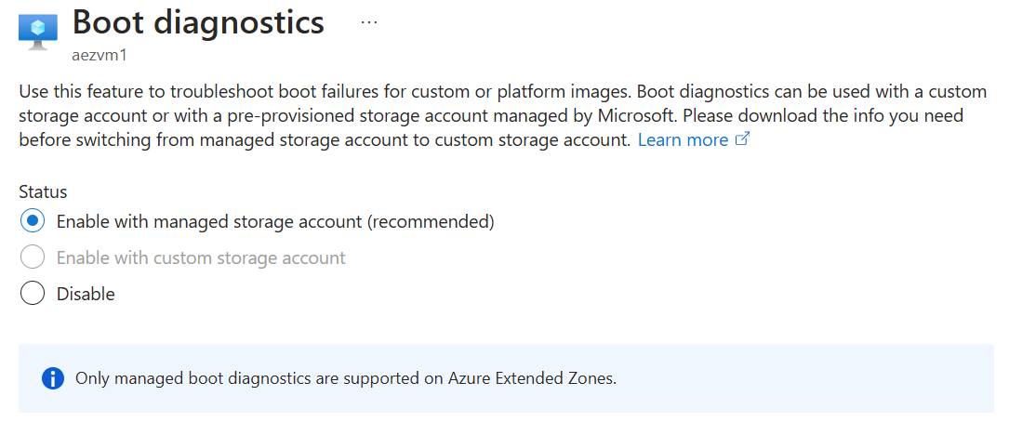

Quotas

Update Management
Quotas for Azure Extended Zones are managed as part of the parent region. Monitoring or alerting on quota consumption specific to Azure Extended Zones is not supported. If there is a need to request a quota increase specific to an Azure Extended Zone, please follow the steps outlined in the Request a quota increase in the Azure portal for Azure Extended Zones document.

Automatic VM guest patching
Automatic virtual machine guest patching is supported for virtual machines deployed within an Azure Extended Zone. This feature should be considered as part of your update management strategy, adhering to the guidelines specified in the official documentation.

Azure Update Manager
Azure Update Manager is a comprehensive service designed to assist in managing and governing updates for all your machines. It provides a unified view for monitoring Windows and Linux update compliance. The service allows for real-time updates or the scheduling of updates within designated maintenance windows.
Integrating Azure Update Manager into your update management strategy is advisable for virtual machines deployed in Azure Extended Zones.

Networking and connectivity

Network Topology
Azure Extended Zones can be deployed in the following scenarios:
- Azure Extended Zone - Standalone
- Azure Extended Zone - Extension

Azure Extended Zone - Standalone
When considering the use of an Azure Extended Zone in a standalone scenario, there are two networking topologies to consider:
- Traditional network
- Azure Virtual WAN

Traditional Network
Traditional Azure network topology configurations can be effectively deployed within an Azure Extended Zone. This includes configurations such as a single virtual network (vNet) or a Hub and Spoke network topology.
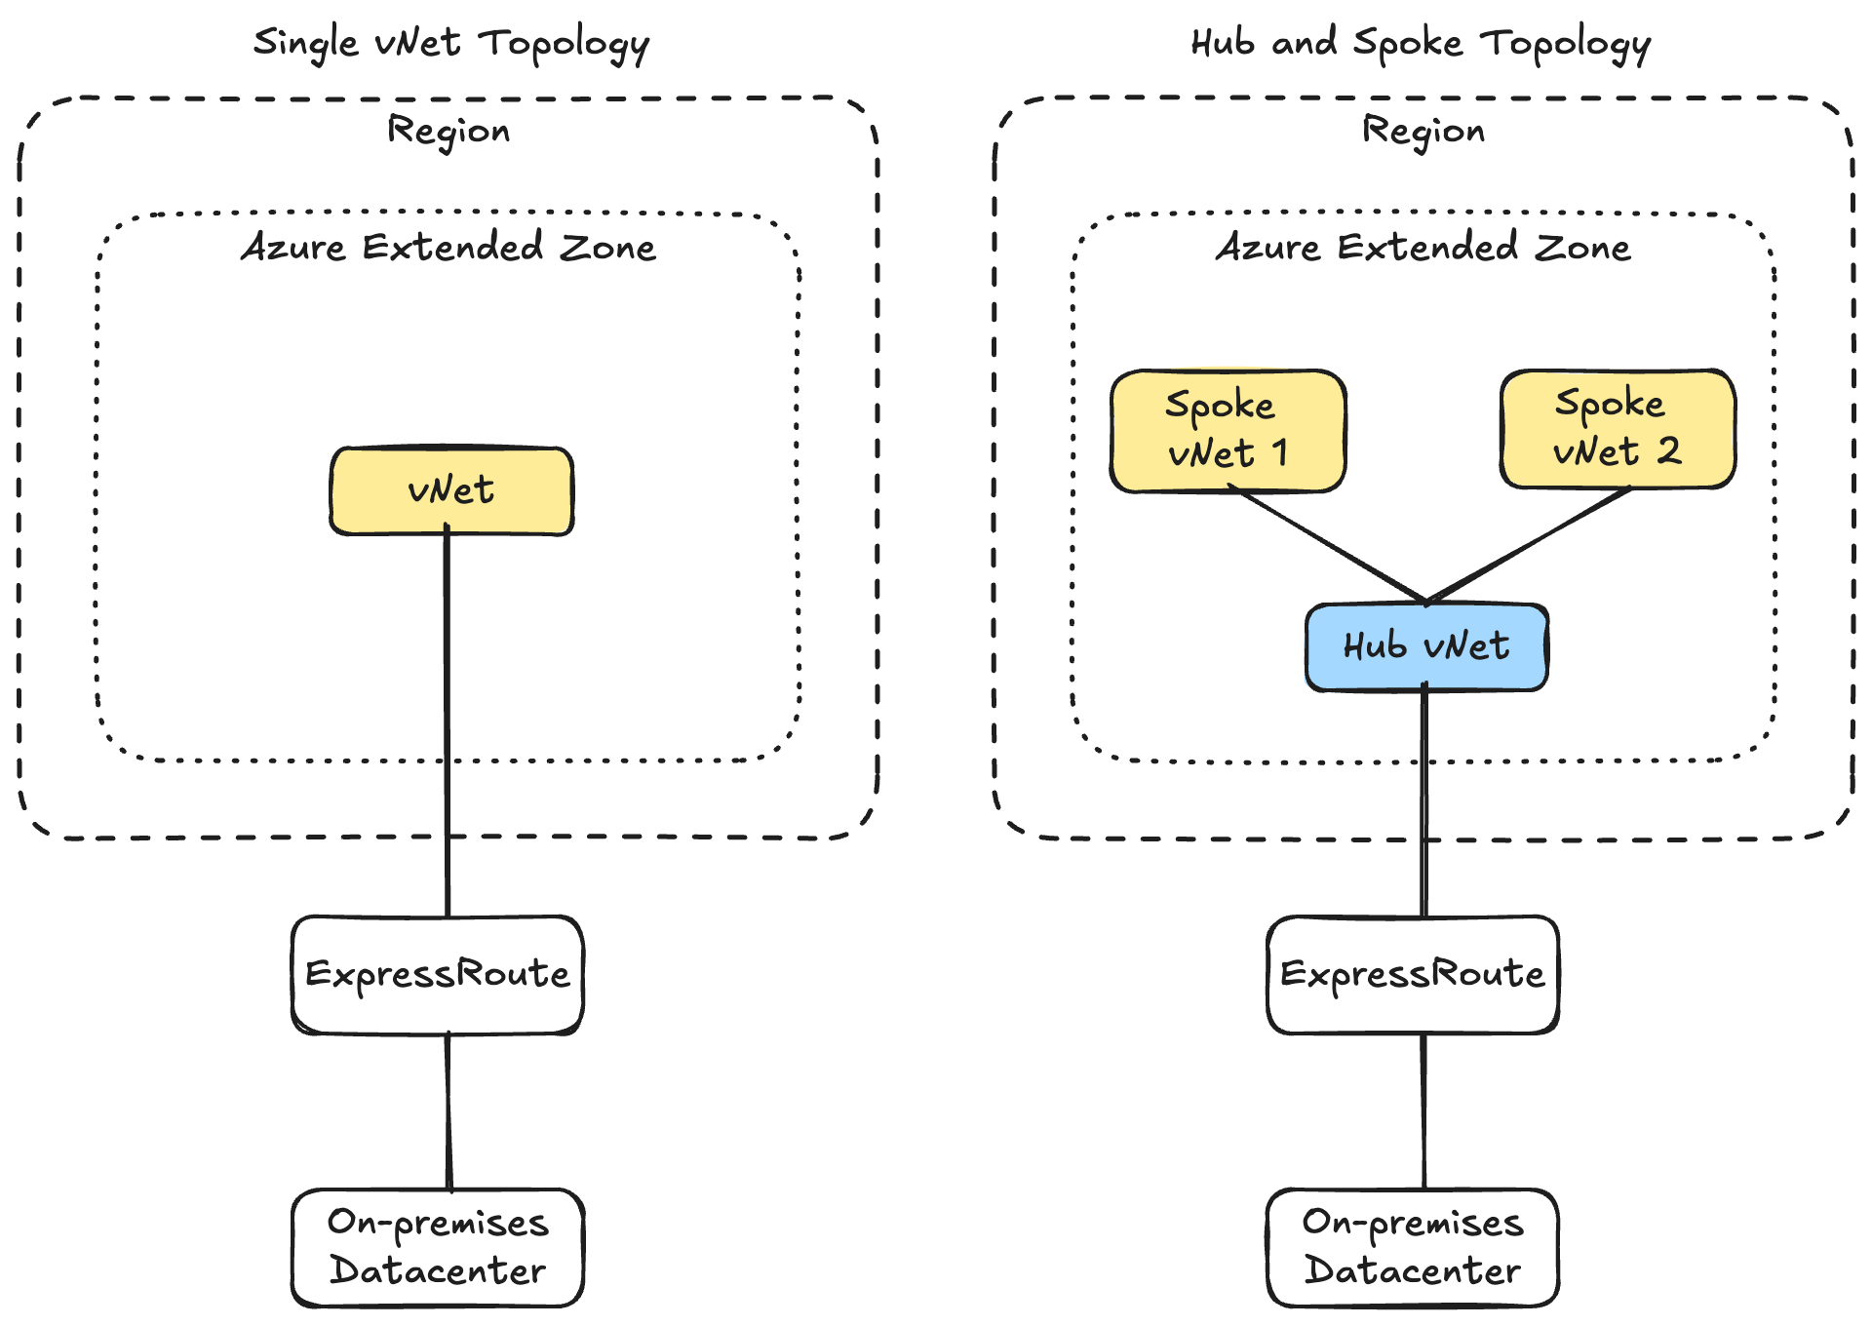

Azure Virtual WAN
The deployment of Azure Virtual WAN Hub within Azure Extended Zones is currently unsupported.
For updates on service availability and timelines, refer to the Service availability and timelines section.

Azure Extended Zone - Extension
When considering the implementation of an Azure Extended Zone in a regional extension scenario, there are two primary networking topologies to evaluate:
- Traditional network
- Azure Virtual WAN

Traditional Network
Traditional Azure network topology configurations can be effectively deployed within an Azure Extended Zone and extended back to the Parent region's network topology. Connectivity between the Extended Zone Hub vNet and the Parent Region Hub vNet will be established via a vNet Peering connection.

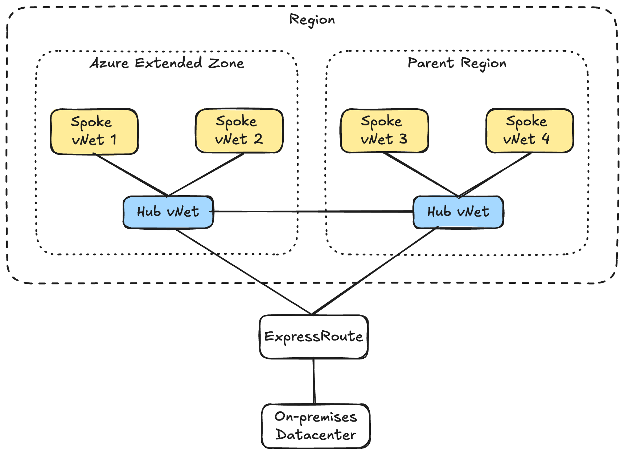

Virtual WAN (Microsoft Managed) - Hybrid
Traditional Azure network topology configurations can be effectively deployed within an Azure Extended Zone and extended back to a Parent Region Azure Virtual WAN. This connection would be established via a vNet peering connection.
The deployment of Azure Virtual WAN Hub within Azure Extended Zones is currently unsupported.
For updates on service availability and timelines, refer to the Service availability and timelines section.

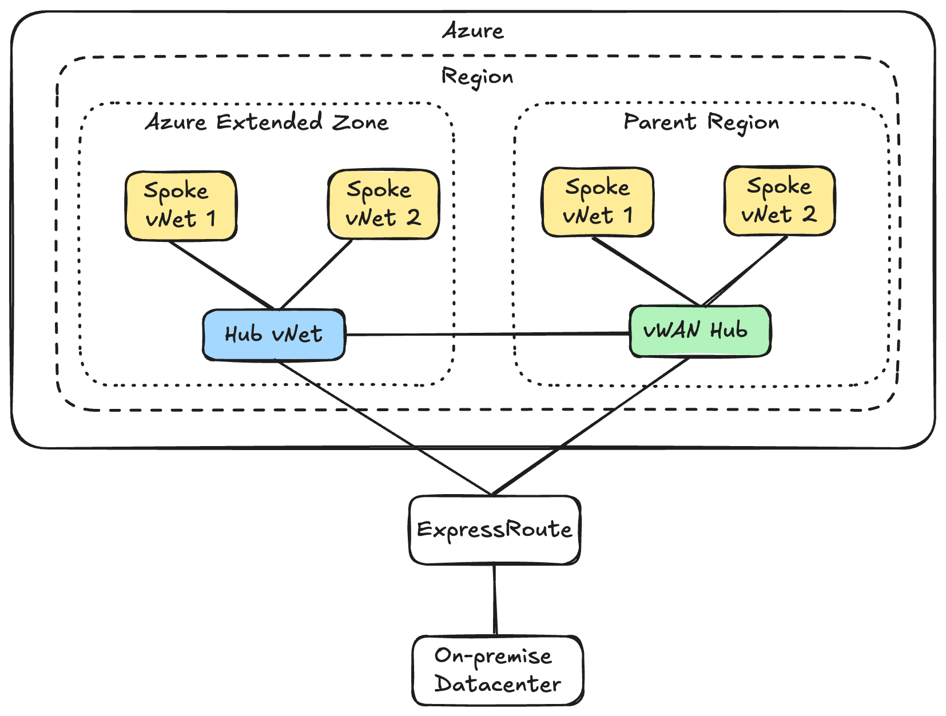

Connectivity Options
Hybrid network connectivity to resources within an Azure Extended Zone can be established through the following methods:
- ExpressRoute
- Site-to-site VPN

ExpressRoute
ExpressRoute is the preferred solution to extend an on-premises network into the Azure Extended Zone.
It is important to note that while there will be two Microsoft Points of Presence (PoP) in Perth, there is only a single ExpressRoute peering location, located at:
- NextDC P1
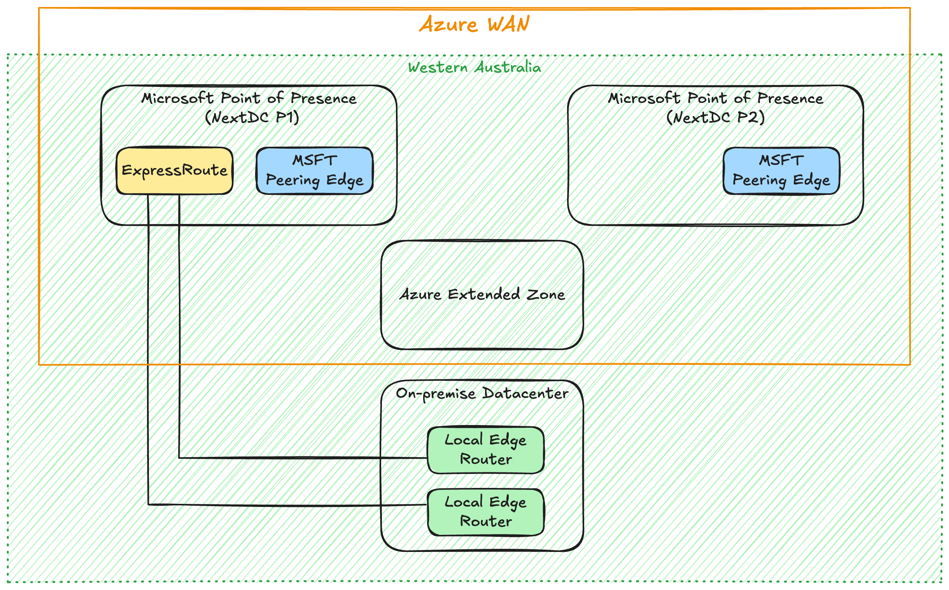

The ExpressRoute circuits can be established through the following partners:
- Equinix
- Megaport
- NextDC
or by using ExpressRoute Direct.

The ExpressRoute circuit are available in the following SKU:
- ExpressRoute Local – currently not supported for Azure Extended Zones
- ExpressRoute Standard – provides connectivity to resources within the Geopolitical boundary (e.g. Oceania includes Australia East, Australia Southeast, New Zealand North)
- ExpressRoute Premium – provides global connectivity over the Microsoft core network, allowing you to link a VNet in one geopolitical region with an ExpressRoute circuit in another region
ExpressRoute Local is not supported for Azure Extended Zones

Availability
ExpressRoute is a highly reliable service, supported by a 99.95% uptime SLA. Many of Microsoft’s largest customers rely on ExpressRoute to connect their on-premises networks to Microsoft resources.
Microsoft incorporates high availability into each layer of the ExpressRoute connection. We provide two separate links for each circuit, each terminating in different physical hardware inside the PoP. If the primary link becomes unavailable, the secondary link can continue to be used. Additionally, ExpressRoute PoPs are designed with a high degree of redundancy and resiliency.
High availability is a shared responsibility. Clients need to utilize both physical links and regularly test their configuration and failover processes. Deployment of your ExpressRoute configuration should adhere to our high availability guidance. Ensure that your side of the connection is free from single points of failure. It is essential that customer premises equipment (CPE) is evaluated to meet high availability requirements. Moreover, application workloads must be capable of handling retries properly, as short, intermittent outages of the ExpressRoute connection are normal and expected within the SLA.

Disaster recovery
Instances of degradation or outages at ExpressRoute peering locations or across an entire regional service can occur, often due to natural calamities. Hence, it is crucial to develop a disaster recovery plan to ensure business continuity and support mission-critical applications.
Although there will be two PoPs in Perth, there is only a single ExpressRoute peering location. To minimize the impact of a peering location failure, the following mitigation options are recommended:
- Deploy a second ExpressRoute circuit, which will connect to another PoP in the parent region (e.g., Sydney). This method is fully detailed in the ExpressRoute disaster recovery guidance. While this approach may result in increased latency due to cross-region traffic, this trade-off is often considered acceptable during disaster scenarios.
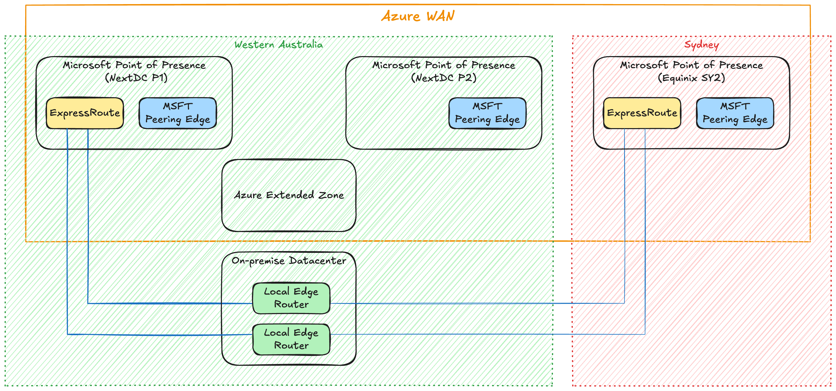
- Use a site-to-site VPN as a fallback.
Each mitigation option introduces additional complexity and expense, making it essential to carefully assess the necessity of such measures before implementation.

Site-to-Site VPN
ISV VPN solutions can be used to establish a site-to-site VPN connection to the Azure Extended Zone to support hybrid connectivity to an on-premises network.
The Azure Extended Zones roadmap includes the Azure VPN Gateway service to allowing being able to send encrypted traffic between an Azure virtual network and on-premises locations over the public Internet.
Review the Service availability and timelines section for availability updates.

Outbound Internet Access
In Azure Extended Zones, there is no default outbound internet access. As the default outbound route is being phased out across all Azure regions by September 2025, Azure Extended Zones will commence without this default outbound internet route.
Attempts to disable the Private Subnet feature will result in the below error message.

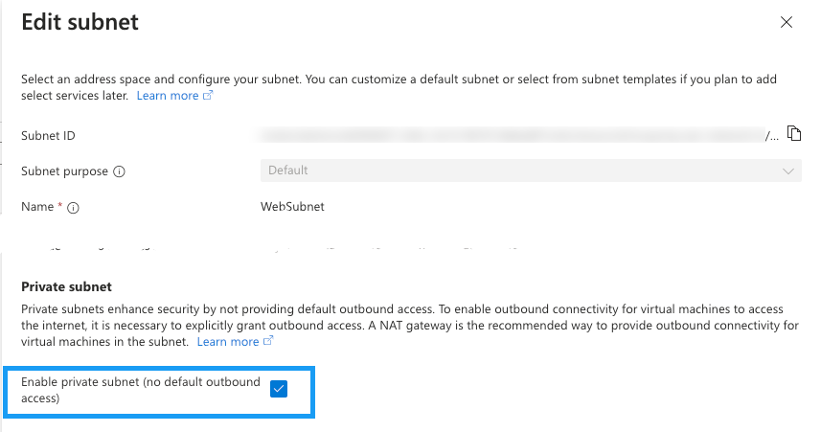
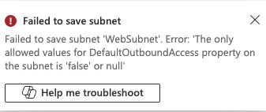

To provide outbound internet access, you should implement one of the following solutions:
- Network Virtual Appliance
- Azure Load Balancer (SNAT)
- Instance Level Public IP
- Azure Firewall (Roadmap)
- NAT Gateway (Roadmap)

Network Virtual Appliance
Network Virtual Appliances (NVA) from ISV (e.g. F5 Networks, Palo Alto, Cisco) can be utilised in the Azure Extended Zone:
- To inspect egress traffic from virtual machines to the Internet and prevent data exfiltration.
- To inspect ingress traffic from the Internet to virtual machines and prevent attacks.
- To filter traffic between virtual machines in Azure to prevent lateral movement of compromised systems.
- To filter traffic between on-premises systems and Azure virtual machines if they are considered to belong to different security levels. For example, if Azure hosts the DMZ and on-premises hosts the internal applications.

Azure Load Balancer
Azure Standard Load Balancer (public) can be utilized to provide outbound internet access via source network address translation (SNAT) for backend instances. This configuration uses SNAT to translate a virtual machine's private IP address into the load balancer's public IP address. SNAT maps the IP address of the backend instance to the public IP address of the load balancer, thereby preventing external sources from directly accessing the backend instances.
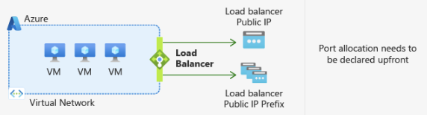

Instance Level Public IP
Assigning a public IP address to a virtual machine instance enables the instance to have direct access to the internet.
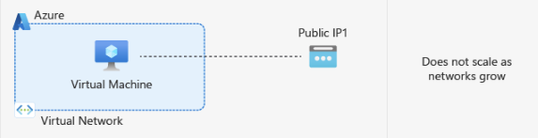

Azure Firewall

NAT Gateway
The Azure Extended Zones roadmap includes the Azure Firewall service to allow all instances in a private subnet to connect outbound to the internet while remaining fully private.
Review the Service availability and timelines section for availability updates.
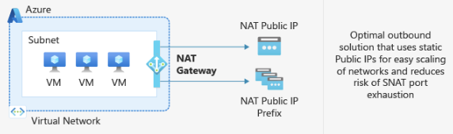
The Azure Extended Zones roadmap includes the NAT Gateway service to allow all instances in a private subnet to connect outbound to the internet while remaining fully private.
Review the Service availability and timelines section for availability updates.

Inbound Internet Access
Azure Extended Zones will offer several solutions to ensure secure access to resources from the internet:
- Azure Load Balancer
- Virtual Network Appliance
- Application Gateway (Roadmap)

Azure Load Balancer
When utilising Azure Load Balancers within an Extended Zone, the following constraints must be considered:
- Only the Azure Standard Load Balancer SKU is supported. Gateway and Basic Load Balancer SKUs are not supported.
- Only the Regional tier is supported.

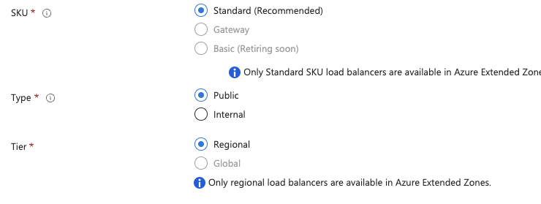

Network Virtual Appliance
Network Virtual Appliances (NVA) from ISV (e.g. F5 Networks, Palo Alto, Cisco) can be utilised in the Azure Extended Zone:
- To inspect egress traffic from virtual machines to the Internet and prevent data exfiltration.
- To inspect ingress traffic from the Internet to virtual machines and prevent attacks.
- To filter traffic between virtual machines in Azure to prevent lateral movement of compromised systems.
- To filter traffic between on-premises systems and Azure virtual machines if they are considered to belong to different security levels. For example, if Azure hosts the DMZ and on-premises hosts the internal applications.

Application Gateway
The Azure Extended Zones roadmap includes the Azure Application Gateway service to provide secure access to resources from the internet.
Review the Service availability and timelines section for availability updates.

Name Resolution

Hybrid DNS Resolution
Hybrid DNS resolution, which allows Azure resources to resolve on-premises domains and enables on-premises DNS to resolve Azure private DNS zones, can be implemented through the following solutions:
- Customer managed DNS server
- Azure Private DNS Resolver

Customer managed DNS server
By deploying a customer managed DNS server into the Azure Extended Zone you will be able to
- Resolve on-premises computer and service names from VMs or role instances in Azure.
- Resolve Azure hostnames from on-premises computers.

Azure Private DNS Resolver
.
The Azure Private DNS Resolver is currently unsupported in the Azure Extended Zones.
Review the Service availability and timelines section for availability updates

Business continuity, disaster recovery and migration
Business Continuity and Disaster Recovery (BCDR) are essential components of a comprehensive cloud strategy, ensuring that applications and data remain accessible and recoverable during disruptions. This section will address the availability and recovery strategies specific to Azure Extended Zones.

Availability

Compute

Availability Sets
Availability sets will not be supported in Azure Extended Zones. For compute resilience within an Extended Zone, Virtual Machine Scale Sets should be utilized.

Azure Virtual Machine Scale Sets
Virtual Machine Scale Sets allow for the creation and management of a group of load-balanced virtual machines. The number of VM instances can automatically scale in accordance with demand or a predefined schedule. Key benefits of scale sets include:
- Streamlined creation and management of multiple VMs
- Enhanced high availability and application resiliency by distributing VMs across availability zones or fault domains
- Automatic scaling of applications in response to fluctuating resource demand
- Capability to operate at large scale

Network

Azure Load Balancer
Azure Load Balancer can significantly enhance application resilience by efficiently distributing incoming network traffic across multiple instances of an application, thereby ensuring high availability and reliability. Here are some key benefits:
- Fault Tolerance: By distributing traffic across multiple instances, Azure Load Balancer ensures that if one instance fails, traffic is automatically redirected to healthy instances, thereby minimizing downtime.
- Scalability: It supports the scaling of applications by adding more instances as required to handle increased traffic, ensuring that the application remains responsive under load.
- Health Probes: Azure Load Balancer uses health probes to monitor the status of application instances. If an instance is found to be unhealthy, the load balancer will stop sending traffic to it until it is healthy again.
- Low Latency and High Throughput: The load balancer provides low latency and high throughput, which is crucial for maintaining performance and reliability in high-traffic scenarios.

Azure Application Gateway

Storage
The Azure Extended Zones roadmap includes the Azure Application Gateway service to provide secure access to resources from the internet.
Review the Service availability and timelines section for availability updates.

Locally Redundant Storage
Locally Redundant Storage (LRS) is supported by Azure Extended Zones, offering data replication three times within the Azure Extended Zone. While this does not safeguard against Azure Extended Zone failures, it provides protection against hardware issues within the zone.
In addition, Azure Storage offers several features to enhance data resiliency:
- Soft Delete: Soft delete helps protect your data from accidental or malicious deletion. When enabled, deleted blobs or containers are retained for a specified period, allowing you to restore them if necessary. This feature is particularly useful for recovering from accidental deletions or overwrites.
- Versioning: Blob versioning automatically maintains previous versions of an object. Each time a blob is modified, a new version is created, allowing you to restore previous versions if necessary. This feature is crucial for data protection and recovery, as it helps revert to earlier states of your data in case of unintended changes.

Recovery

Data Protection
Azure Backup is an essential service for safeguarding resources within Azure, including virtual machines (VMs), Azure Files, Azure Disks, and Azure Blobs. Azure Extended Zones support the use of Azure Backup to protect assets within the Extended Zone.
It is important to note that Recovery Services Vaults can only be created in an Azure Region and not within Azure Extended Zones. To ensure robust data protection, it is advisable to replicate backup data to another Azure region. For Azure Extended Zones, a parent region must act as the control plane, providing oversight and management capabilities for these zones.
The following Azure Backup scenarios are currently supported:
- Azure Extended Zone > Parent region
The following Azure Backup scenarios are not currently supported:
- On-premises > Azure Extended Zone

Disaster Recovery
Azure Site Recovery (ASR) is a Microsoft Azure service designed to ensure business continuity by maintaining the operation of applications and workloads during outages. ASR accomplishes this by replicating workloads running on physical and virtual machines (VMs) from a primary site to a secondary location. In the event of an outage at the primary site, the service enables failover to the secondary location, ensuring continuous access to applications. Once the primary site is restored, you can fail back to it seamlessly.
The following ASR scenarios are currently supported:
- Azure Extended Zone > Parent region
The following ASR scenarios are not currently supported:
- Azure Extended Zone > Non-parent region
- Azure Extended Zone > Azure Extended Zone
- On-premises > Azure Extended Zone
- On-premises > Azure Extended Zone – Storage Account (for Cache) > Region
- On-premises > Azure Extended Zone

Migration
Azure Migrate does not support the migration of workloads to Azure Extended Zones..
Review the Service availability and timelines section for availability updates.

If you are considering migrating workloads from on-premises to an Azure Extended Zone, consult with your Microsoft account team for tailored recommendations and guidance.

Security, compliance and data residency
Azure provides a comprehensive framework to ensure the security, compliance, and proper data residency of your cloud resources. This framework is meticulously designed to protect your data, adhere to regulatory requirements, and ensure that data is stored and processed in appropriate locations.
This section will discuss important considerations for Azure Extended Zones.

Microsoft Cloud Security Benchmark
The Microsoft cloud security benchmark (MCSB) provides prescriptive best practices and recommendations that enhance the security of workloads, data, and services on Azure and across your multi-cloud environment. This benchmark focuses on cloud-centric control areas with input from various Microsoft and industry security guidelines, including:
- Cloud Adoption Framework: Offers guidance on strategy, roles and responsibilities, Azure Top 10 Security Best Practices, and reference implementation.
- Azure Well-Architected Framework: Provides insights on securing your workloads on Azure.
- Chief Information Security Officer (CISO) Workshop: Delivers program guidance and strategies to accelerate security modernization using Zero Trust principles.
- Industry and cloud service provider security best practice standards and frameworks: Includes examples such as the Amazon Web Services (AWS) Well-Architected Framework, Center for Internet Security (CIS) Controls, National Institute of Standards and Technology (NIST), and Payment Card Industry Data Security Standard (PCI-DSS).
It is recommended to consult MCSB and the service baselines for any service deployed to an Azure Extended Zone to plan for the security configuration of each service.

Cloud Security Posture Management
Microsoft Defender for Cloud is a comprehensive cloud-native application protection platform (CNAPP) designed to safeguard cloud-based applications from a wide range of cyber threats and vulnerabilities. Defender for Cloud integrates the following capabilities:
- Development Security Operations (DevSecOps): This solution unifies security management at the code level across multicloud and multiple-pipeline environments.
- Cloud Security Posture Management (CSPM): CSPM surfaces actionable insights to prevent breaches and strengthen security posture.
- Cloud Workload Protection Platform (CWPP): CWPP provides specific protections for servers, containers, storage, databases, and other workloads.
It is advisable to utilize Microsoft Defender for Cloud to manage and enhance the security posture of the Azure Extended Zone.

Security Information and Event Management
Microsoft Sentinel is a scalable, cloud-native Security Information and Event Management (SIEM) system that offers a comprehensive solution for both SIEM and Security Orchestration, Automation, and Response (SOAR). This service is designed to provide robust cyber threat detection, investigation, response, and proactive threat hunting across your entire enterprise infrastructure.
Microsoft Sentinel seamlessly integrates with proven Azure services such as Log Analytics and Logic Apps, enhancing investigation and detection capabilities with advanced artificial intelligence. It leverages Microsoft's extensive threat intelligence stream and also allows integration of user-provided threat intelligence.
For effective SIEM and SOAR within the Azure Extended Zone, Microsoft Sentinel is highly recommended. Detailed information on deploying the Log Analytics workspace for Microsoft Sentinel can be found in the Logs section of this document.

Azure Security Services

Network Security Groups
An Azure Network Security Group (NSG) is instrumental in filtering network traffic between Azure resources within an Azure virtual network. Each NSG comprises security rules that either allow or deny inbound and outbound network traffic based on specified source and destination, port, and protocol parameters.
It is noteworthy that when a virtual machine (VM) is created within an Azure Extended Zone and the option to create an NSG is selected, the NSG will automatically be established in the resource group's region corresponding to the Azure Extended Zone VM, i.e., the parent region.

Azure Private Link
Azure Private Link enables secure and private access to Azure PaaS services, such as Azure Storage and SQL Database, as well as customer-owned and partner services hosted on Azure, via a private endpoint within your virtual network. This ensures that traffic between your virtual network and the service traverses the Microsoft backbone network, eliminating the need for exposure to the public internet.

DDoS
Azure DDoS Protection, combined with application design best practices, provides enhanced DDoS mitigation features to defend against DDoS attacks. It's automatically tuned to help protect your specific Azure resources in a virtual network.
Azure DDoS Protection, combined with application design best practices, provides enhanced DDoS mitigation features to defend against DDoS attacks. It's automatically tuned to help protect your specific Azure resources in a virtual network. Protection is simple to enable on any new or existing virtual network, and it requires no application or resource changes.
Azure DDoS Protection protects at layer 3 and layer 4 network layers. For web applications protection at layer 7, you need to add protection at the application layer using a WAF offering. For more information, see Application DDoS protection.
It is necessary to create the DDoS Protection plan in the Parent Region rather than the Azure Extended Zone. Customers and partners should utilize the DDoS Protection plan in the parent region to safeguard their resources deployed in Azure Extended Zones.
For protection against L7 application layer attacks, deploy Azure Web Application Firewall (WAF) with either Azure Front Door Premium or Application Gateway WAF v2 SKU. Azure Application Gateway is included in the Azure Extended Zone roadmap. For updates on service availability and timelines, please review the corresponding section.
A multi-layered security approach, incorporating network, application, and data protection, should always be implemented.

Azure Firewall
Azure Firewall is a cloud-native and intelligent network firewall security service designed to offer superior threat protection for your cloud workloads operating within Azure. It is a fully stateful firewall service with built-in high availability and unlimited cloud scalability. Azure Firewall provides comprehensive traffic inspection for both east-west and north-south traffic flows. For an in-depth explanation of these traffic types, please refer to the section on East-West and North-South Traffic.
The Azure Extended Zones roadmap includes the Azure Firewall service to allow all instances in a private subnet to connect outbound to the internet while remaining fully private.
Review the Service availability and timelines section for availability updates.

Data residency
You might choose to utilize an Azure Extended Zone to meet data residency requirements for your workloads within the Microsoft cloud.
It is important to note that, in certain limited scenarios, data may be stored outside of your selected geography. For further details, please refer to the section on Data residency in Azure.
Additionally, if you employ a broad range of Azure services, multiple regions may be necessary as not all services are available in all regions or within the Azure Extended Zone. It is crucial to carefully assess the availability of services within the Azure Extended Zone or the designated parent region(s). Please consult the Service availability and timelines section for more information. If your required services are not available in the parent region(s) or Azure Extended Zone, you should evaluate other regions that offer an optimal balance between data residency requirements, resource costs, and latency.

Extended Security Updates
Extended Security Updates (ESUs) will be provided at no additional cost for customers utilizing Azure services. This includes workloads operating on Azure Virtual Machines, Azure Dedicated Host, Azure VMware Solutions, Nutanix Cloud Clusters on Azure, and Azure Stack Hub/Edge/HCI. In the Azure Extended Zone, eligible virtual machines (VMs) configured to receive updates will automatically benefit from ESUs, ensuring continuous compliance and security updates without incurring extra charges.
For more information refer to FAQ in MS Docs.

Compliance and regulatory standards
Azure Extended Zones meet the following compliance standards:
ISO 27001, SOC 2 type II report, and PCI DSS

Use cases (coming soon)

The information contained in this document represents the current view of Microsoft Corporation on the issues discussed as of the date of publication. Because Microsoft must respond to changing market conditions, it should not be interpreted to be a commitment on the part of Microsoft, and Microsoft cannot guarantee the accuracy of any information presented after the date of publication.
This white paper is for informational purposes only. Microsoft makes no warranties, express or implied, in this document.
Complying with all applicable copyright laws is the responsibility of the user. Without limiting the rights under copyright, no part of this document may be reproduced, stored in, or introduced into a retrieval system, or transmitted in any form or by any means (electronic, mechanical, photocopying, recording, or otherwise), or for any purpose, without the express written permission of Microsoft Corporation.
Microsoft may have patents, patent applications, trademarks, copyrights, or other intellectual property rights covering subject matter in this document. Except as expressly provided in any written license agreement from Microsoft, the furnishing of this document does not give you any license to these patents, trademarks, copyrights, or other intellectual property.
© 2023 Microsoft Corporation. All rights reserved.
Microsoft and other trademarks are either registered trademarks or trademarks of Microsoft Corporation in the United States and/or other countries.

